**~~Plastics~~: Are we plasticizing the world like the Midas touch?**

Abhishek Prakash Angne

X18136923

MSc Data Analytics – Cohort ‘B’

Data Visualization CA 2

21st July 2019

**1. Introduction**

A demonic wave in disguise of convenience engulfed the world in the late 1950’s in the form of plastics. [1]That was the beginning of the so called ‘Plastic Age’. Plastics, sadly, have been an essential part of the life on earth. Aquatic life, human life and animal life were slowly yet effectively getting a taste of the overpowering plastic dependency of the industrial world. [2]A report on Marine Pollution by Jenna R. Jambeck in the year 2015 highlights plastic waste from land entering the waters highlights the negative effects of ocean gyres, whirlpooling plastic waste thus further fragmenting it down to microplastics. These microplastics are ingested by invertebrates due to their miniscule nature.

[3]Various domains have been explored through this infographic to bring to life the different aspects that highlight the ill-effects of plastics on the environment, specifically, oceans. Oceans in turn, have a major impact on rainfall, therefore on nature, food production, and therefore on all aspects of life on earth.

**2. Process – The story behind making the story**

[4]The thought process behind creating this infographic came from an inevitable dependability on plastic that the world has created for several products that is harming the environment in the manner of a nuclear chain reaction. This unstoppable dependency is a cycle that needs to break and individual awareness. [5]A **Z-pattern** is used to present the topic in a stepwise manner with a combination of graphs, icons, facts, and charts. A rough wireframe was created on a sheet of paper to create a rough sketch of where to place the facts and figures to depict significant information in a simple, precise and effective manner. The infographic is split into 8 different parts with charts and graphics to illustrate the significance of stopping the use of plastic. An apt title was chosen for depicting the exact meaning in the quickest manner and eye-catching manner in colours resonant with the respective colour scheme of the project. [6]Charts and figures were constructed using Canva, a tool for creating informative visuals and was changed and modified meet Kirk’s principles (KIRK, 2019) for storytelling of the data being trustworthy, accessible and elegant and meet the overall requirement ****of the right design, colours, icons ad structured content to deliver the message in the most effective manner.

**3. Background on Datasets**

A total of six datasets and seven facts have been referenced and used to develop this infographic.

The following aspects are depicted with **semantically resonant colours** and positioning in an orderly manner following a **Z-pattern** of designing infographics:

1. [7]Global plastic production (million metric tonnes) -

This dataset was extracted from Statista.com and it helps the viewer easily understand the exponential increment in plastic production over a span of almost six decades 1950 onwards. With more in-depth research about the data and timeline of this particular visual we can understand how plastic slowly replaced metal, glass, and wood as the raw material for a plethora of daily products, equipment, and possibly all the dimensions of life right from drinking water bottles to bin bags.

There’s a fact on how long a plastic bottle takes to decompose (Postconsumers, 2019) if it doesn’t get recycled.

1. [8]Mismanaged plastic waste - 2010 (million metric tonnes)

This dataset was compiled based on research performed by Jenna Jambeck and a research team consisting of researchers from Australia and the US. She analysed the level of plastic waste in the oceans around the world.

The chart clearly depicts how China was responsible for mismanaging the most amount of waste in the year 2010, i.e. around 8.82 million metric tons (Our World in Data, 2019) that ended up in global waters. This trend kept going for the coming 8 years before they banned the import of worldwide plastic for the purpose of recycling. This is explained in detail in the fact mentioned right below the table chart. This chart was completely developed using Canva. The icons used are from Canva’s own collection of icons freely available for reuse for projects. The map icon of Indonesia was picked up from www.flaticons.com.

1. [9]Countries plasticizing the oceans (BBC News, 2019) -

This chart is one of the most detailed aspect of this infographic. It gives information on gyres, 15 countries with mismanaged plastic waste, the great pacific garbage patch, and number of plastic pieces floating in respective oceans.

1. [10]Facts on Ireland and China on plastic waste and recycling and total plastic pieces floating on all the oceans of the world –

The fact says that there are 5.25 trillion plastic pieces in the ocean (PLOS|One, 2019). This data was extracted from an article from the journal which is one Ireland’s prime news website. It infers that Ireland is EU’s biggest plastic waste producer and China takes 95% of this waste for the purpose of recycling. It also brings to surface the fact that every person living in Ireland produces approximately 61 Kg of plastic waste on a yearly basis.

1. ****[11]A fact on What are Gyres?

A quick fact giving a comprehensive insight on what gyres are.

1. A quote on microplastics:

This quote is placed to introduce and explain the gravity of the situation of the ever-increasing amount of microplastics in the ocean being more in number in comparison to stars in the milky way.

1. [12]An informative numeric fact on microplastics -

This infographic depicts the process of plastic breakage into microplastics due to whirlpooling currents carried by gyres. It also explains how plastics affect the food cycle.

1. [13]Sources of ocean microplastics -

This data was extracted up from statista.com and it describes the sources from where microplastics are released into the ocean and/or environment and therefore, into the oceans.

1. [14]Plastic, a toxic?

Data for this section was extracted from the web source mentioned in the footnote. It mentions how plastics become microplastics and how their toxicity shoots up after further breakdown.

1. [15]Recycling, what?

This fact box speaks about the coming future and how the plasticizing will eventually affect the overall disposal and recycling of plastics post China’s ban on importing plastic for the purposes of recycling effective from January 2018.

**4. Specification:**

The infographic was constructed using the following specifications:

**a. Information on the background of the infographic**:  
The background image of the infographic was selected from Canva’s own collection of freely available for premium users. The backdrop or background was chosen to facilitate and signify the presence of plastics in the ocean. A plastic bag can be spotted in the mid-right half of the infographic. The colour of the text in this location is black as to maintain the overall visibility of text. The remainder of the document comprises of white text. The black here signifies visibility and one of the most crucial facts in the infographic. The bottles right below this depict the fact in a graphical manner.

**b. Information on the header**:  
The title half consists of the title, subtitle, two icons and one crucial fact on the ill effects of plastics on aquatic life during recent times. The cross sign on plastics speaks about quitting or limiting the use of plastics for survival of the future generations and preserving mother earth from the ill-effects of chemicals. The title and subtitle are written using Lato Bold font style. The remainder of the ****document consists of the font Droid Serif. The ship and the whale are picked up for significant reasons. The ship is perfectly placed to on the ocean and tilted to match the wave and face the heading. Similarly, the whale is strategically placed besides the shocking fact about the death of a whale in Philippines wherein it faces the title. This semantic positioning equidistant helps in creating an impact on the visual in focus.

**c. Overview of the overall of the plastic production and mismanagement of plastic waste:**

Charts, facts, and maps in the first half of the infographic give quick insights about the production of plastics overall in the world. A staggering figure of 348 million metric tons of plastic was created in the year 2017. A subtle fact about the timeframe for plastic bottle decomposition brings forth a strong fact to discontinue plastic bottle usage. [16]Social media expert, entrepreneur Amada Cerny is fighting against the use of such bottles, cups, and straws for a plastic-free tomorrow. Facts about China being the highest importer and bad manager of waste is highlighted. Ireland’s dominance in creating plastic waste in the EU is also a shocking fact brought to light. The second half of the infographic speaks about gyre’s, the ‘Great Pacific Garbage Patch’ (WorldAtlas, 2019) between Hawaii and California. This section depicts the number of plastic pieces floating in the ocean is brought up as one of the most horrifying number.

Moving further, the infusion of microplastics in nature brings to light how plastics have become a part of earth till extinction due to their miniscule size. The fact about microplastics being of a higher number than the number of stars in the milky way explains the severity of the situation. The sources of microplastics that come from industrial products and the toxicity in the long run carried by that this overtly loved material is brought to notice.

**The infographic ends with why plastics cannot be completely recycled on time and why banning plastics is the best solution, exactly what the title says.**

**5. Justification:**

To create a detailed and clean infographic, an agile technique is utilized to create a skeleton.

The infographic addresses a real-life problem of the ever-increasing use of plastics. A simple and [17]effective design principle is utilized to achieve all the principles of creating a good infographic by Andy Kirk. Data was extracted from multiple legible sources for the creation of insightful charts.

**a. Techniques**:

Different charts were used to depict different types of information. A line graph was used to depict time series data. Qualitative and quantitative analysis was employed for correct chart selection. A horizontal bar chart has been used to show multiple values of an aspect. A map chart was used for geographical data for countries and oceanic data representation. A table chart has been used for displaying data in a tabular format to crucial facts in the simplest possible manner.

**b. Layout:**

The layout and design of this infographic was designed while comparing the story that is being told. The infographic is split into five sections. The five sections go from plastic production, mismanagement, oceanic pollution, the wrath of microplastics and the crisis of recycling plastics.****

**c. Style:**

A Z-strategy was used to order the data. Droid Serif is the font used for the overall infographic and Lato bold is used for the header and subtitle section. This was done to clearly differentiate between the header section and the content. Multiple font sizes have been used in accordance of variability in focus. Font size ’59’ has been used for headings, ‘39’ for text and ‘35’ for legends.

**d. Colours, Icons and Annotations:**

The idea of keeping it simple has been used in the selection of colours. Semantically resonant colour scheme has been used. **White (#ffffff)**, **Red (#dd2e44)**, **black (#000000)**, and **blue (#09728d)** have been used. The colour white has been used to depict plastic, blue to represent water, red to determine danger, and black to increase visibility when a certain section was lighter. Annotations have been used to highlight important facts. Various icons have been used to depict location, plastic bottles, water, aquatic life, earth, industries, toxicity, gyres, plastic bags, map icons, flags, human face and other minute details. Slight transparency has been used to improve visibility. The wave diagram on the white plastic background depicts the fact in a precise manner.

**6. Technologies used**:

a. [18]Canva: Used to create the infographic and visualiztions.

b.[19]Photoscape: Used for editing the image, icons, charts and adding effects.

c. Microsoft Excel: Used for data organization.

d. [20]Pixabay: Icons were taken from here.

e. [21]Flaticons: Icons were taken from here.

**7. Reflection**: The topic was selected looking at the miserable plastic management which is an inevitable global crisis. Datasets were carefully constructed and finalized to tell a precise story. The planning and designing took the most amount of time. A paper-based wireframe was first created, and facts were organized in a rough manner. The best ones were displayed. No template was used. The image was picked up and everything was built on the image. A story was made by keeping in mind aspects like heuristics, positioning, a zig-zag direction. Multiple iterations were made before reaching the final design. The most crucial aspects of alignment and direction were like the cherry on the cake to complete the design.

This research helped me in learning a lot about the hazards of plastics and I’ve therefore tried keeping plastics to a minimum.

**8. Infographic:**

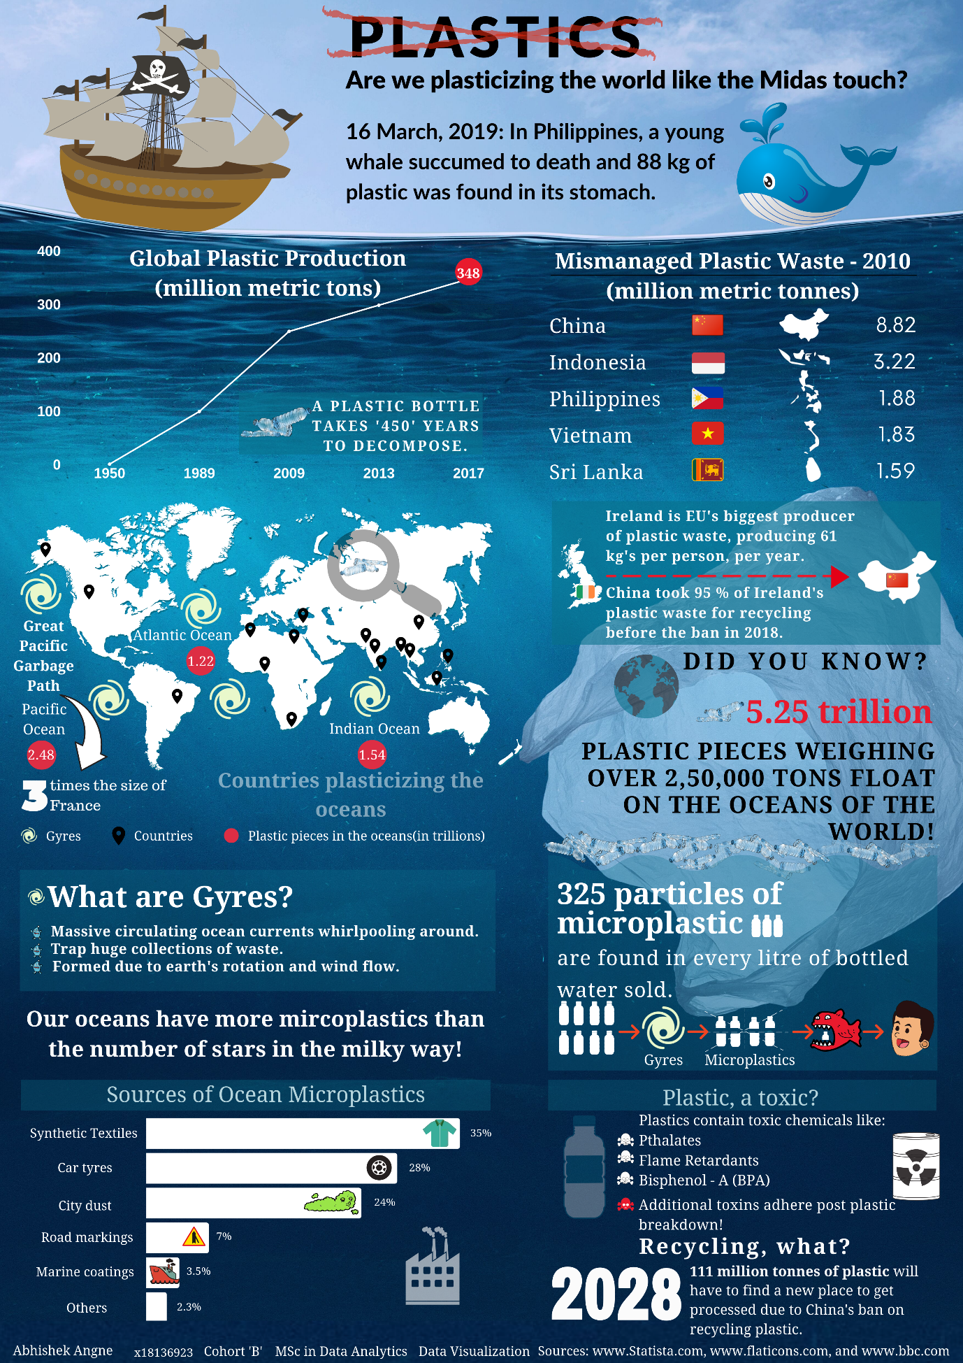

**9. Appendix**:

Wireframe 1: This is a rough representation of the infographic created above. A lot of changes were made to the initial design after multiple iterations.

****Rough data preparation Wireframe 2:

**10. References**:

1. PLOS|One. (2019). *Plastic Pollution in the World's Oceans: More than 5 Trillion Plastic Pieces Weighing over 250,000 Tons Afloat at Sea*. [online] Available at: https://journals.plos.org/plosone/article/figure?id=10.1371/journal.pone.0111913.g002 [Accessed 21 Jul. 2019].

2. KIRK, A. (2019). *DATA VISUALISATION*. [S.l.]: SAGE PUBLICATIONS. [Accessed 21 Jul. 2019].

3. Postconsumers. (2019). *How Long Does It Take a Plastic Bottle to Biodegrade? - Postconsumers*. [online] Available at: https://www.postconsumers.com/2011/10/31/how-long-does-it-take-a-plastic-bottle-to-biodegrade/ [Accessed 21 Jul. 2019].

4. WorldAtlas. (2019). *What Is An Ocean Gyre?*. [online] Available at: https://www.worldatlas.com/articles/what-is-an-ocean-gyre.html [Accessed 21 Jul. 2019].

5. BBC News. (2019). *How does plastic move around the oceans?*. [online] Available at: https://www.bbc.com/news/av/science-environment-44377953/how-does-plastic-move-around-the-oceans [Accessed 21 Jul. 2019].

6. Our World in Data. (2019). *FAQs on Plastics*. [online] Available at: https://ourworldindata.org/faq-on-plastics [Accessed 21 Jul. 2019].

1. <https://www.motherearthliving.com/health-and-wellness/harmful-effects-of-plastic-ze0z1205zsch>
2. <https://www.iswa.org/fileadmin/user_upload/Calendar_2011_03_AMERICANA/Science-2015-Jambeck-768-71__2_.pdf>
3. <https://www.netflix.com/ie/title/80049832>
4. <https://www.visualisingdata.com/>
5. <https://moodle.ncirl.ie/pluginfile.php/456904/mod_resource/content/0/Data%20Visualization%20-%20Lecture%2005.pdf>
6. <https://us.sagepub.com/sites/default/files/upm-binaries/75674_Kirk_Data_Visualisation.pdf>
7. <https://www.statista.com/statistics/282732/global-production-of-plastics-since-1950/>
8. https://www.statista.com/chart/12211/the-countries-polluting-the-oceans-the-most/
9. https://www.statista.com/chart/12211/the-countries-polluting-the-oceans-the-most/
10. https://www.thejournal.ie/ireland-plastic-waste-3786393-Jan2018/
11. <https://www.bbc.com/news/science-environment-43490235>
12. https://www.worldatlas.com/articles/what-is-an-ocean-gyre.html
13. https://www.statista.com/statistics/909561/sources-of-ocean-microplastics/
14. <http://www.oneworldoneocean.com/blog/entry/plastics-breakdown-an-infographic>
15. https://www.dailymail.co.uk/sciencetech/article-5867343/China-block-plastic-waste-cause-worldwide-pile-study-says.html
16. <https://liveforlivemusic.com/news/amanda-cerny-play-it-out-2019/>
17. <https://us.sagepub.com/sites/default/files/upm-binaries/75674_Kirk_Data_Visualisation.pdf>
18. <https://www.canva.com/>
19. <http://www.photoscape.org/ps/main/index.php>
20. <https://pixabay.com/>
21. <https://www.flaticon.com/home>